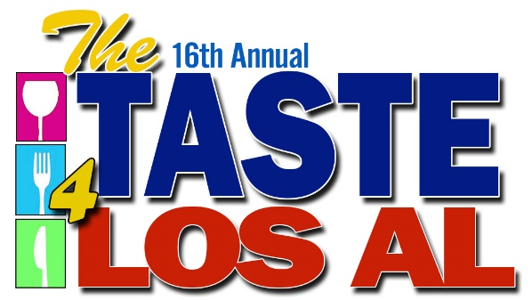

October 15 _ Saturday - 6pm - 10pm
The Shops at Rossmoor

OUR Los Al/Taste for Los Al – where does money go?
- Raised over $2.1 million NET since 2001
- Activities
  - majority of monies go directly to booster clubs
  - Ticket sales, auction, raffles, etc.
- Facilities
  - $238,000 to all-weather track
also gym scoreboard, softball backstop & fencing, tennis windscreen, locker room improvements, etc.
- Support
  - Los Al TV broadcast coverage of activities

Tickets:
    - Ticket price: $45 – Checks made out to OUR LOS AL
    - Selling club receives $25 per ticket IF money, ticket stubs, and completed EXCEL Spreadsheet are turned in by September 30;
      - if received between Oct 1-7, club receives $10 per ticket
      - club receives no money back for tickets turned in after Oct. 10
      - Online Ticket Sales – same deadlines as above except sales will close online Oct. 13. Purchasers need to BRING THEIR ONLINE PRINT-OUT for entry.

Provide Volunteers:
    - each club provide volunteers for one 2-hour shift over event weekend
    - all student volunteers must be supervised
    - issues with timeslot assignments talk to Diana Hill

Additional fundraising opportunities:
- Sponsorships, Banners
  - If clubs sell event sponsorships, they keep 50% (see sponsorship form provided)
- Fundraising Nights
- Silent Auction:
  - Table Cost is $60
    - covers table, linens and amortized cost of tent, lighting, etc.
    - A form will be sent to your SA chair and/or Taste Rep.
Due back around the first of October
  - Each club is responsible for running its own Silent Auction.
    - includes procuring items, setting up tables, bid sheets and taking payment and taking away your stuff that night, etc
  - High Valued Section - Big Ticket Items (Travel, Sports/Entertainment, etc.)
    - separate area at front of Silent Auction Tent. This section will close last. Each table space (15” wide) costs $15 (covers table, linens, tent, and security).
NOTE: MANDATORY SILENT AUCTION meeting Friday evening Oct. 14!
- Gear Table (for selling Griffin Gear, raffle/drawing tickets, etc.
  - Cost $40 for a 6 foot table located amidst restaurant tables
  - NOTE: (If you sell tickets for anything, design MUST be cleared by us to prevent confusion with OUR Los Al drink tickets and other clubs’ tickets)
  - No clubs can sell any tickets outside the gate

Items that will be emailed to you:
- Ticket Spreadsheet
- Silent Auction Table Request Form
- Logo
- Sponsorship Flyer & Reservation Form
- Volunteer Time Assignments

Important Dates:

August 22 Ticket Distribution
September 3o First ticket turn in day -- $25 back
October 7 Last ticket turn in day -- $10 back
October 13 Online ticket sales end
October 14 Volunteer setup 2-4pm, 4-6pm
Silent Auction Meeting – 6pm
October 15 Day of the Event
Volunteer setup 10am–12pm, 1-3pm
Silent Auction Setup – 2-4pm
October 16 Clean up – 10:30am–12:30pm

Have More Questions??

For tickets, or booster club issues:

Diana Hill – Booster Club Liaison – dhill@dianadhill.com
562-598-8350 office · 310-720-7677 cell
Location for additional ticket pickup and drop off:
12042 Paseo Bonita, Los Alamitos, CA 90720

For Excel Spreadsheet questions –

Nancy Strawther
(562) 522-6912
nancystrawther@gmail.com

For all other Taste or OUR Los Al questions

Larry Strawther
larrystrawther@gmail.com
(562) 522-6670 cell
(562) 431-7001 office

